**DENSITY BASED TRAFFIC LIGHT CONTROL SYSYTEM**

G.VASANTHA(AP17110020031)

G. KANISHKA REDDY (AP17110020043)

SRINIVAS MURTHY (AP17110020041)

SAI DEEKSHITH (AP17110020040)

DEPARTMENT OF

ELECTRONICS AND COMMUNICATION ENGINEERING

IN SRM UNIVERSITY, AP, AMARAVATI.

**ABSTRACT:**

In present, vehicular trafficis increasing throughoutthe world, especiallyin large urban areas. As the number of

road user’s increase constantly and current resources& infrastructures being limited; a smart traffic control will

become a very importantissue in the future. Theseneeds have led to an ever increasing demand for an“intelligent”

traffic control system.Therefore, optimization of traffic control to better accommodatethis increasingdemand is

needed. Our project willdemonstrate the optimization of trafficlights in a city using wireless sensors. Traffic light

optimization is a tough problem. With multiple junctions, the complexity increases as the state of one light node

influences the flow of traffictowards many other nodes. We proposed a trafficlight controllerthat allowsus to

control and study different situations of traffic density. We sense the density of traffic using infra-red sensors. The

key role behind the implementation of the “Traffic density based light control system” is to make use of an

AT89C51 controller which performs processing of the real time data provided by theinfra -red sensors, eventually

controlling the traffic flow via the LED traffic light

In present, vehicular trafficis increasing throughoutthe world, especiallyin large urban areas. As the number of

road user’s increase constantly and current resources& infrastructures being limited; a smart traffic control will

become a very importantissue in the future. Theseneeds have led to an ever increasing demand for an“intelligent”

traffic control system.Therefore, optimization of traffic control to better accommodatethis increasingdemand is

needed. Our project willdemonstrate the optimization of trafficlights in a city using wireless sensors. Traffic light

optimization is a tough problem. With multiple junctions, the complexity increases as the state of one light node

influences the flow of traffictowards many other nodes. We proposed a trafficlight controllerthat allowsus to

control and study different situations of traffic density. We sense the density of traffic using infra-red sensors. The

key role behind the implementation of the “Traffic density based light control system” is to make use of an

AT89C51 controller which performs processing of the real time data provided by theinfra -red sensors, eventually

controlling the traffic flow via the LED traffic light

In present, vehicular trafficis increasing throughoutthe world, especiallyin large urban areas. As the number of

road user’s increase constantly and current resources& infrastructures being limited; a smart traffic control will

become a very importantissue in the future. Theseneeds have led to an ever increasing demand for an“intelligent”

traffic control system.Therefore, optimization of traffic control to better accommodatethis increasingdemand is

needed. Our project willdemonstrate the optimization of trafficlights in a city using wireless sensors. Traffic light

optimization is a tough problem. With multiple junctions, the complexity increases as the state of one light node

influences the flow of traffictowards many other nodes. We proposed a trafficlight controllerthat allowsus to

control and study different situations of traffic density. We sense the density of traffic using infra-red sensors. The

key role behind the implementation of the “Traffic density based light control system” is to make use of an

AT89C51 controller which performs processing of the real time data provided by theinfra -red sensors, eventually

controlling the traffic flow via the LED traffic light

n present, vehicular trafficis increasing throughoutthe world, especiallyin large urban areas. As the number of

road user’s increase constantly and current resources& infrastructures being limited; a smart traffic control will

become a very importantissue in the future. Theseneeds have led to an ever increasing demand for an“intelligent”

traffic control system.Therefore, optimization of traffic control to better accommodatethis increasingdemand is

needed. Our project willdemonstrate the optimization of trafficlights in a city using wireless sensors. Traffic light

optimization is a tough problem. With multiple junctions, the complexity increases as the state of one light node

influences the flow of traffictowards many other nodes. We proposed a trafficlight controllerthat allowsus to

control and study different situations of traffic density. We sense the density of traffic using infra-red sensors. The

key role behind the implementation of the “Traffic density based light control system” is to make use of an

AT89C51 controller which performs processing of the real time data provided by theinfra -red sensors, eventually

controlling the traffic flow via the

n present, vehicular trafficis increasing throughoutthe world, especiallyin large urban areas. As the number of

road user’s increase constantly and current resources& infrastructures being limited; a smart traffic control will

become a very importantissue in the future. Theseneeds have led to an ever increasing demand for an“intelligent”

traffic control system.Therefore, optimization of traffic control to better accommodatethis increasingdemand is

needed. Our project willdemonstrate the optimization of trafficlights in a city using wireless sensors. Traffic light

optimization is a tough problem. With multiple junctions, the complexity increases as the state of one light node

influences the flow of traffictowards many other nodes. We proposed a trafficlight controllerthat allowsus to

control and study different situations of traffic density. We sense the density of traffic using infra-red sensors. The

key role behind the implementation of the “Traffic density based light control system” is to make use of an

AT89C51 controller which performs processing of the real time data provided by theinfra -red sensors, eventually

controlling the traffic flow via the

n present, vehicular trafficis increasing throughoutthe world, especiallyin large urban areas. As the number of

road user’s increase constantly and current resources& infrastructures being limited; a smart traffic control will

become a very importantissue in the future. Theseneeds have led to an ever increasing demand for an“intelligent”

traffic control system.Therefore, optimization of traffic control to better accommodatethis increasingdemand is

needed. Our project willdemonstrate the optimization of trafficlights in a city using wireless sensors. Traffic light

optimization is a tough problem. With multiple junctions, the complexity increases as the state of one light node

influences the flow of traffictowards many other nodes. We proposed a trafficlight controllerthat allowsus to

control and study different situations of traffic density. We sense the density of traffic using infra-red sensors. The

key role behind the implementation of the “Traffic density based light control system” is to make use of an

AT89C51 controller which performs processing of the real time data provided by theinfra -red sensors, eventually

controlling the traffic flow via the

In present, vehicular trafficis increasing throughoutthe world, especiallyin large urban areas. As the number of

road user’s increase constantly and current resources& infrastructures being limited; a smart traffic control will

become a very importantissue in the future. Theseneeds have led to an ever increasing demand for an“intelligent”

traffic control system.Therefore, optimization of traffic control to better accommodatethis increasingdemand is

needed. Our project willdemonstrate the optimization of trafficlights in a city using wireless sensors. Traffic light

optimization is a tough problem. With multiple junctions, the complexity increases as the state of one light node

influences the flow of traffictowards many other nodes. We proposed a trafficlight controllerthat allowsus to

control and study different situations of traffic density. We sense the density of traffic using infra-red sensors. The

key role behind the implementation of the “Traffic density based light control system” is to make use of an

AT89C51 controller which performs processing of the real time data provided by theinfra -red sensors, eventually

controlling the traffic flow via the LED traffic lights.

In present, vehicular trafficis increasing throughoutthe world, especiallyin large urban areas. As the number of

road user’s increase constantly and current resources& infrastructures being limited; a smart traffic control will

become a very importantissue in the future. Theseneeds have led to an ever increasing demand for an“intelligent”

traffic control system.Therefore, optimization of traffic control to better accommodatethis increasingdemand is

needed. Our project willdemonstrate the optimization of trafficlights in a city using wireless sensors. Traffic light

optimization is a tough problem. With multiple junctions, the complexity increases as the state of one light node

influences the flow of traffictowards many other nodes. We proposed a trafficlight controllerthat allowsus to

control and study different situations of traffic density. We sense the density of traffic using infra-red sensors. The

key role behind the implementation of the “Traffic density based light control system” is to make use of an

AT89C51 controller which performs processing of the real time data provided by theinfra -red sensors, eventually

controlling the traffic flow via the LED traffic lights.

At present vehicular traffic is increasing throughout the world, especially in large urban areas. As the number of road user's increase constantly and current resources & infrastructures being limited, a smart traffic control will become a very important issue in the future. These needs have led to anever-increasing demand for a smart traffic control system. Therefore, optimization of traffic control to better accommodate this increasing demand is needed. Our project will demonstrate the optimization of traffic lights in a city using sensors. Traffic light optimization is a tough problem. With multiple junctions, the complexity increases as the state of one light node influences the flow of traffic towards many other nodes. We proposed a sensor that allows us to study different situations of traffic density and help us control the traffic. We sense the density of traffic using passive infra-red sensors.

In the past, the researchers had gone through different types of technologies. Brief surveys of various

solutions of the traffic congestion problems are presented. RFID & GSM is mentioned in the Road Traffic

Congestion Monitoring and Measurement using Active RFID and GSM Technology [8]. In this system active RFID

tag, wireless coordinator, wireless router, GSM modems and monitoring station software are used. Here the wireless

devices are mounted on either sides of the road and they collect the data from the active RFID tags. Through GSM,

monitoring station will collect all the data and respond to the corresponding traffic signal. WSN was presented in the

Priority Based Traffic Lights Controller Using Wireless Sensor Networks. In this a wireless sensor network is being

used. To define the direction of any emergency vehicle, system uses a fuzzy logic and by collecting all the

information the central monitoring system gives the corresponding appropriate response. The traffic lights that are in

In the past, the researchers had gone through different types of technologies. Brief surveys of various

solutions of the traffic congestion problems are presented. RFID & GSM is mentioned in the Road Traffic

Congestion Monitoring and Measurement using Active RFID and GSM Technology [8]. In this system active RFID

tag, wireless coordinator, wireless router, GSM modems and monitoring station software are used. Here the wireless

devices are mounted on either sides of the road and they collect the data from the active RFID tags. Through GSM,

monitoring station will collect all the data and respond to the corresponding traffic signal. WSN was presented in the

Priority Based Traffic Lights Controller Using Wireless Sensor Networks. In this a wireless sensor network is being

used. To define the direction of any emergency vehicle, system uses a fuzzy logic and by collecting all the

information the central monitoring system gives the corresponding appropriate response. The traffic lights that are in

In the past, the researchers had gone through different types of technologies. Brief surveys of various

solutions of the traffic congestion problems are presented. RFID & GSM is mentioned in the Road Traffic

Congestion Monitoring and Measurement using Active RFID and GSM Technology [8]. In this system active RFID

tag, wireless coordinator, wireless router, GSM modems and monitoring station software are used. Here the wireless

devices are mounted on either sides of the road and they collect the data from the active RFID tags. Through GSM,

monitoring station will collect all the data and respond to the corresponding traffic signal. WSN was presented in the

Priority Based Traffic Lights Controller Using Wireless Sensor Networks. In this a wireless sensor network is being

used. To define the direction of any emergency vehicle, system uses a fuzzy logic and by collecting all the

information the central monitoring system gives the corresponding appropriate response. The traffic lights that are in

In the past, the researchers had gone through different types of technologies. Brief surveys of various

solutions of the traffic congestion problems are presented. RFID & GSM is mentioned in the Road Traffic

Congestion Monitoring and Measurement using Active RFID and GSM Technology [8]. In this system active RFID

tag, wireless coordinator, wireless router, GSM modems and monitoring station software are used. Here the wireless

devices are mounted on either sides of the road and they collect the data from the active RFID tags. Through GSM,

monitoring station will collect all the data and respond to the corresponding traffic signal. WSN was presented in the

Priority Based Traffic Lights Controller Using Wireless Sensor Networks. In this a wireless sensor network is being

used. To define the direction of any emergency vehicle, system uses a fuzzy logic and by collecting all the

information the central monitoring system gives the corresponding appropriate response. The traffic lights that are in

In the past, the researchers had gone through different types of technologies. Brief surveys of various

solutions of the traffic congestion problems are presented. RFID & GSM is mentioned in the Road Traffic

Congestion Monitoring and Measurement using Active RFID and GSM Technology [8]. In this system active RFID

tag, wireless coordinator, wireless router, GSM modems and monitoring station software are used. Here the wireless

devices are mounted on either sides of the road and they collect the data from the active RFID tags. Through GSM,

monitoring station will collect all the data and respond to the corresponding traffic signal. WSN was presented in the

Priority Based Traffic Lights Controller Using Wireless Sensor Networks. In this a wireless sensor network is being

used. To define the direction of any emergency vehicle, system uses a fuzzy logic and by collecting all the

information the central monitoring system gives the corresponding appropriate response. The traffic lights that are in

**PROBLEM STATEMENT:**

Traffic congestion is increasing on the road day- by- day. As a result of which, two main issues arises. The issues

are no traffic, but still need to wait Heavy traffic jams. These problems occur due to fixed control on traffic. This

research will aim to control the traffic according to the density, but in manner of programming which is already

fixed in the system

Traffic congestion is increasing on the road day- by- day. As a result of which, two main issues arises. The issues

are no traffic, but still need to wait Heavy traffic jams. These problems occur due to fixed control on traffic. This

research will aim to control the traffic according to the density, but in manner of programming which is already

fixed in the system

Traffic congestion is increasing on the road’s day by day. As a result of which some issues arise. No traffic, but we still need to wait for the signal because of the fixed time for signal change irrespective of the traffic. This project will aim to control the traffic according to the density.

**COMPONENTS:**

1. Arduino MEGA
2. PIR Sensor
3. Led lights
4. Resistors
5. Jumper wires
6. Bread board

**SOFTWARE:**

Arduino IDE

**INSTRUMENT DESCRIPTION:**

**PIRSensor**:

PIR sensors allow you to sense motion, almost always used to detect whether an object has moved in or out of the sensors range. They are small, inexpensive, low-power, easy to use and don't wear out. For that reason, they are commonly found in appliances and gadgets used in homes or businesses. They are often referred to as PIR, "Passive Infrared", "Pyroelectric", or "IR motion" sensors.  
  
PIRs are basically made of a [pyroelectric sensor](http://en.wikipedia.org/wiki/Pyroelectric), which can detect levels of infrared radiation. Everything emits some low-level radiation, and the hotter something is, the more radiation is emitted. The sensor in a motion detector is split in two halves. The reason for that is that we are looking to detect motion (change) not average IR levels. The two halves are wired up so that they cancel each other out. If one half sees IR radiation than the other, the output will swing high or low.

**ADVANTAGES:**

* Traffic supervisor with high accuracy and reliability.
* Regulates the dense traffic with less operational speed.
* Reduces waiting time when less traffic.

**CIRCUIT DIAGRAM:**

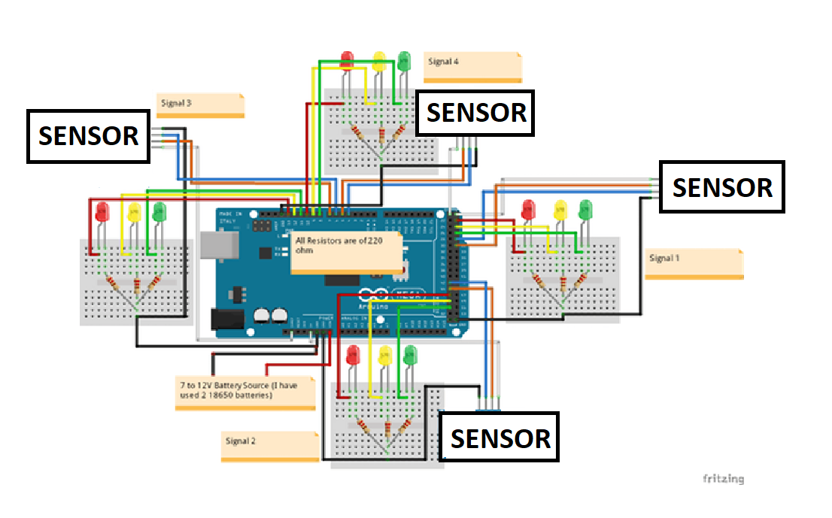

**RESULT AND ANALYSIS:**

Case 1

In this case the density is highest on the road 1 due to the presence of vehicle on road 1.The higher density will cause the green light on road 1 will go green while red light will occur for road 2,road 3 & road 4.

Case 2

In this case density occurs at road 2 resulting in the green light to go green on road 2 and remaining road 1, road 3 &road 4 has red lights.

Case 3

In this case density occurs at road 3 resulting in the green light to go green on road 3 and red light occurs for road1, road2 & road4 respectively.

Case 4

In this case density occurs at road 4 resulting in the green light to go green on road 4 and red light occurs for road 1, road2& road3 respectively.

Case 5

In this case when there is no high trafficand a road is empty with no vehicles, priority is given to other roads by skipping green light to the empty road.

**CONCLUSION:**

In this research we have worked on Congestion problem for such special areas which have dense traffic density. The system works on traffic related problems such as traffic jam, unreasonable latency time of stoppage of vehicle. By using this system configuration, we try to reduce the possibilities of traffic jams, caused by traffic lights. Number of passing vehicle in the fixed time slot on the road decide the density range of traffic and based on vehicle density calculation, according to the information given by the sensor, the traffic light delays are decided.

**Future Scope:**

The Future scope includes Profiling of the traffic by storing the data and managing the traffic lights according to the collected data. The Profiling can also be used for Traffic study and the variation in traffic density throughout the day, week, month or a year. Further, we can optimize this system for the emergency Vehicles such as Ambulance using radio frequencies. The Traffic data collected can be used to locate different routes for a specific daily vehicle to avoid the congestion problem.

**References:**

Hamaidualaki<https://www.researchgate.net/publication/331160723_Design_and_Development_of_a_Traffic_Density_Detection_and_Signal_Adjustment_System>

[lady ada](https://learn.adafruit.com/users/adafruit2)<https://learn.adafruit.com/pir-passive-infrared-proximity-motion-sensor/how-pirs-work> 2019.

G.Lakshminarasimhan , TRAFFIC DENSITY DETECTION AND SIGNAL AUTOMATION USING IOT <https://acadpubl.eu/jsi/2017-116-13-22/articles/21/57.pdf>, 2017.

Electronixc hub <https://www.electronicshub.org/density-based-traffic-signal-system-using-microcontroller/> 2015.